 



Database Programming with SQL 8-1: Group Functions

Practice Activities

# Objectives

* Define and give an example of the seven group functions: SUM, AVG, COUNT, MIN, MAX, STDDEV, VARIANCE
* Construct and execute a SQL query using group functions
* Construct and execute group functions that operate only with numeric data types

# Vocabulary

Identify the vocabulary word for each definition below.

|  |  |
| --- | --- |
| **AVG** | Calculates average value excluding nulls |
| **COUNT** | Returns the number of rows with non-null values for the expression |
| **STDDEV** | For two sets of data with approximately the same mean, the greater the spread, the greater the standard deviation. |
| **Любая групповая функция** | Operate on sets of rows to give one result per group |
| **MIN** | Returns minimum value ignoring nulls |
| **VARIANCE** | Used with columns that store numeric data to calculate the spread of data around the mean |
| **SUM** | Calculates the sum ignoring null values |
| **MAX** | Returns the maximum value ignoring nulls |
| Агрегирующие функции | To gather into a sum or whole |

# Try It / Solve It

1. Define and give an example of the seven group functions: AVG, COUNT, MAX, MIN, STDDEV, SUM, and VARIANCE.

AVG – среднее значение, COUNT – количество элементов, MAX -максимальный элемент, MIN – Минимальный элемент, STDDEV – стандартное отклонение массива, SUM – сумма всех элементов,

VARIANCE – дисперсия массива

1. Create a query that will show the average cost of the DJs on Demand events. Round to two decimal places.

**SELECT ROUND(AVG(cost),2) as "Average Cost"**

**FROM d_events;**

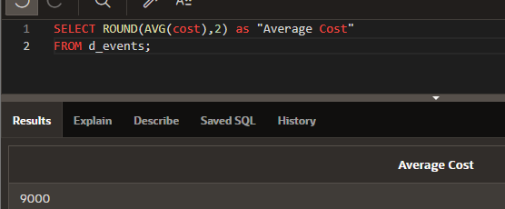

1. Find the average salary for Global Fast Foods staff members whose manager ID is 19.

**SELECT TO_CHAR(ROUND(AVG(salary),2), '$999999.99') as "Average Salary"**

**FROM f_staffs**

**WHERE manager_id = 19;**

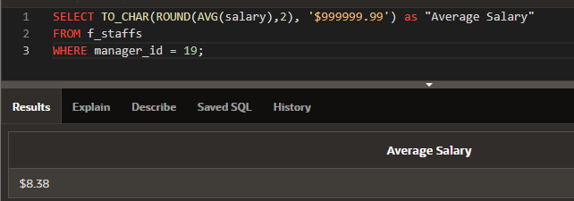

1. Find the sum of the salaries for Global Fast Foods staff members whose IDs are 12 and 9.

**SELECT TO_CHAR(ROUND(SUM(salary),2), '$999999.99') as "Total Salary"**

**FROM f_staffs**

**WHERE id in (12, 19);**

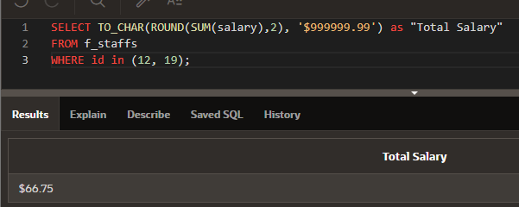

1. Using the Oracle database, select the lowest salary, the most recent hire date, the last name of the person who is at the top of an alphabetical list of employees, and the last name of the person who is at the bottom of an alphabetical list of employees. Select only employees who are in departments 50 or 60.

**SELECT MIN(salary) "lowest salary", MAX(hire_date) "most recent hire date", MIN(last_name) "top last name", MAX(last_name) "bottom last name"**

**FROM employees**

**WHERE department_id in (50, 60);**

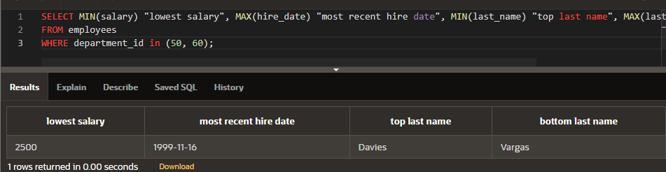

1. Your new Internet business has had a good year financially. You have had 1,289 orders this year. Your customer order table has a column named total_sales. If you submit the following query, how many rows will be returned?

SELECT sum(total_sales) FROM orders;

Одно значение вернется

1. You were asked to create a report of the average salaries for all employees in each division of the company. Some employees in your company are paid hourly instead of by salary. When you ran the report, it seemed as though the averages were not what you expected—they were much higher than you thought! What could have been the cause?

Если использовать AVG с NVL то игнорируемые пустые поля будут учитываться

1. Employees of Global Fast Foods have birth dates of July 1, 1980, March 19, 1979, and March 30, 1969. If you select MIN(birthdate), which date will be returned?

**March 30, 1969**

1. Create a query that will return the average order total for all Global Fast Foods orders from January 1, 2002, to December 21, 2002.

**SELECT 'Average of ' || COUNT(order_number) || '  orders is : ' || AVG(NVL(order_total, 0)) as "Average"**

**FROM f_orders**

**WHERE order_date BETWEEN TO_DATE('January 1, 2002', 'fmMonth DD, YYYY') AND TO_DATE('December 21, 2002', 'fmMonth DD, YYYY');**

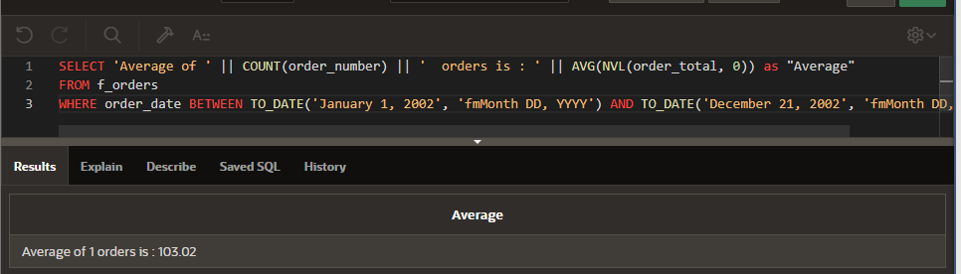

1. What was the hire date of the last Oracle employee hired?

**SELECT MAX(hire_date) as "the last"**

**FROM employees;**

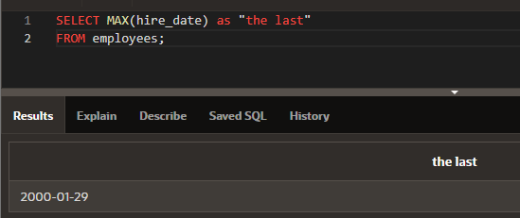

1. In the following SELECT clause, which value returned by the SELECT statement will be larger?

SELECT SUM(operating_cost), AVG(operating_cost)

СУММА будет определенно больше, чем среднее значение (если значение не одно, если одно, то равны)

1. Refer to the DJs on Demand database D_EVENTS table:

Which code is valid as part of an SQL query?

a. FROM event_date Это столбец а не таблица

b. SELECT SUM(cost) Тут все правильно

c. SELECT SUM(event_date) Неверный тип данных

d. SELECT AVG(cost) AS "Expense" Все правильно

e. WHERE MIN(id) = 100 Такая конструкция не сработает, это групповая функция

f. SELECT MAX(AVG(cost)) Такая конструкция не сработает так как MAX на одном значении

g. SELECT MIN(event_date) Тут все правильно